Assignment 35.1

Problem Statement:

● Create a employee table in Mysql and columns as Emp_id, Emp_name, Dept_name(Hadoop Developer), Emp_sal.

● Import the employee table contents into the HDFS directory using Sqoop.

● Create a employee2 table in Mysql and Export employee details file from HDFS directory to Mysql table employee2 using Sqoop.

● Explain the procedures performed, Share the screenshots of commands and results for the same.

● Create a employee table in Mysql and columns as Emp_id, Emp_name, Dept_name(Hadoop Developer), Emp_sal.

● Import the employee table contents into the HDFS directory using Sqoop.

A table has been created with name **employee**and with the columns **emp_id,emp_name,emp_dept,emp_sal.**The scheme of this table can be checked using the following command:

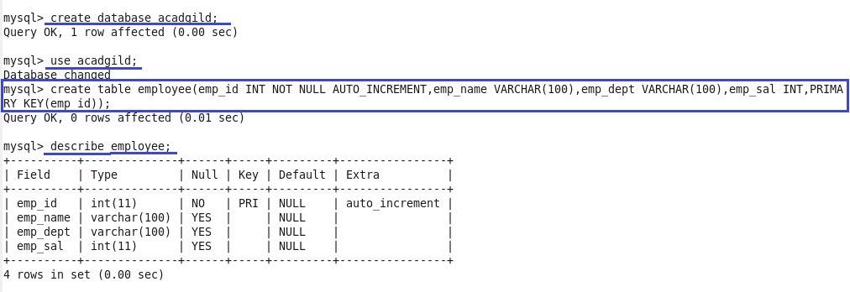

some sample data inserted into the created table by using the below command:

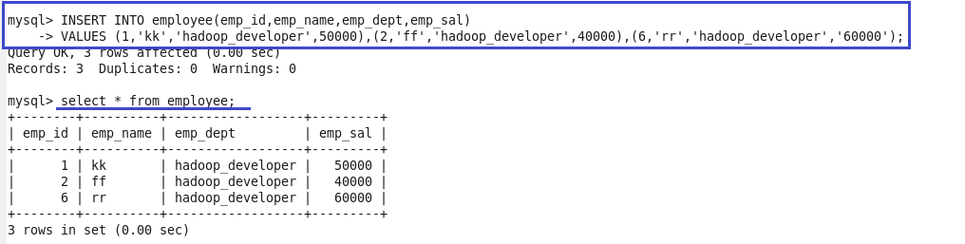

We have successfully created a table in MySQL, and we will now import the same into HDFS by using Sqoop.

The following command can be used to import the table into HDFS.

Here we are connecting to MySQL through JDBC connectors and using the database **acadgild.**Here it is necessary to specify the **MySQL ‘s username and password**and the **table name.**

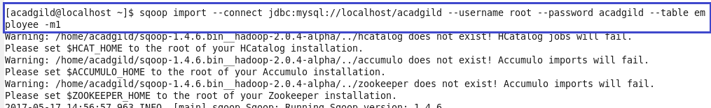

Here ‘-m’ specifies the number of map task that can be run simultaneously and ‘m1’ means that only one map task can run.

Now the data in MySQL has been successfully imported into HDFS. By default, the files will be stored here: **/user/$user_name/table_name/part-m-00000**file.

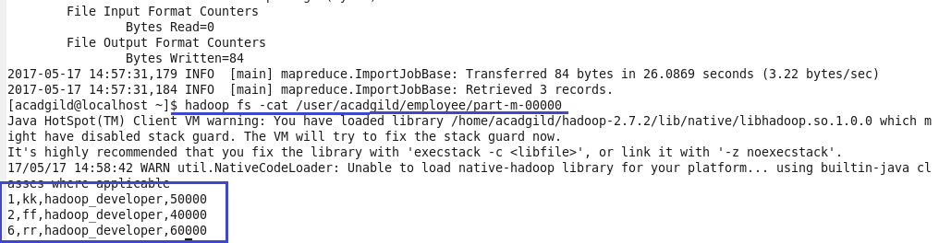

● Create a employee2 table in Mysql and Export employee details file from HDFS directory to Mysql table employee2 using Sqoop.

● Explain the procedures performed, Share the screenshots of commands and results for the same.

A table employee2 is created in mysql with same schema as employee table

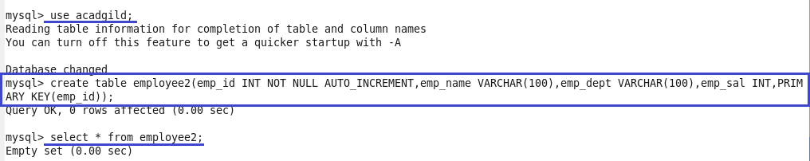

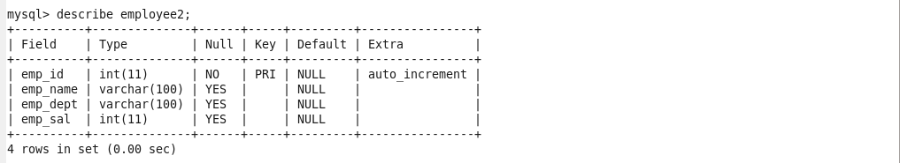

The contents of table employee in hdfs directory are displayed.

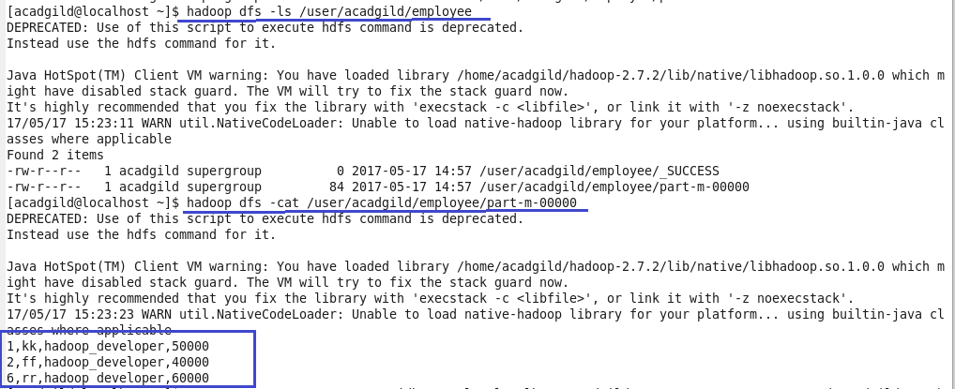

The following command is used to export the data from hdfs directory employee to table employee2 in mysql using sqoop tool.



The data in table employee2 is displayed.

